Duration of the Master’s Degree Program with Thesis
GRADUATE SCHOOL
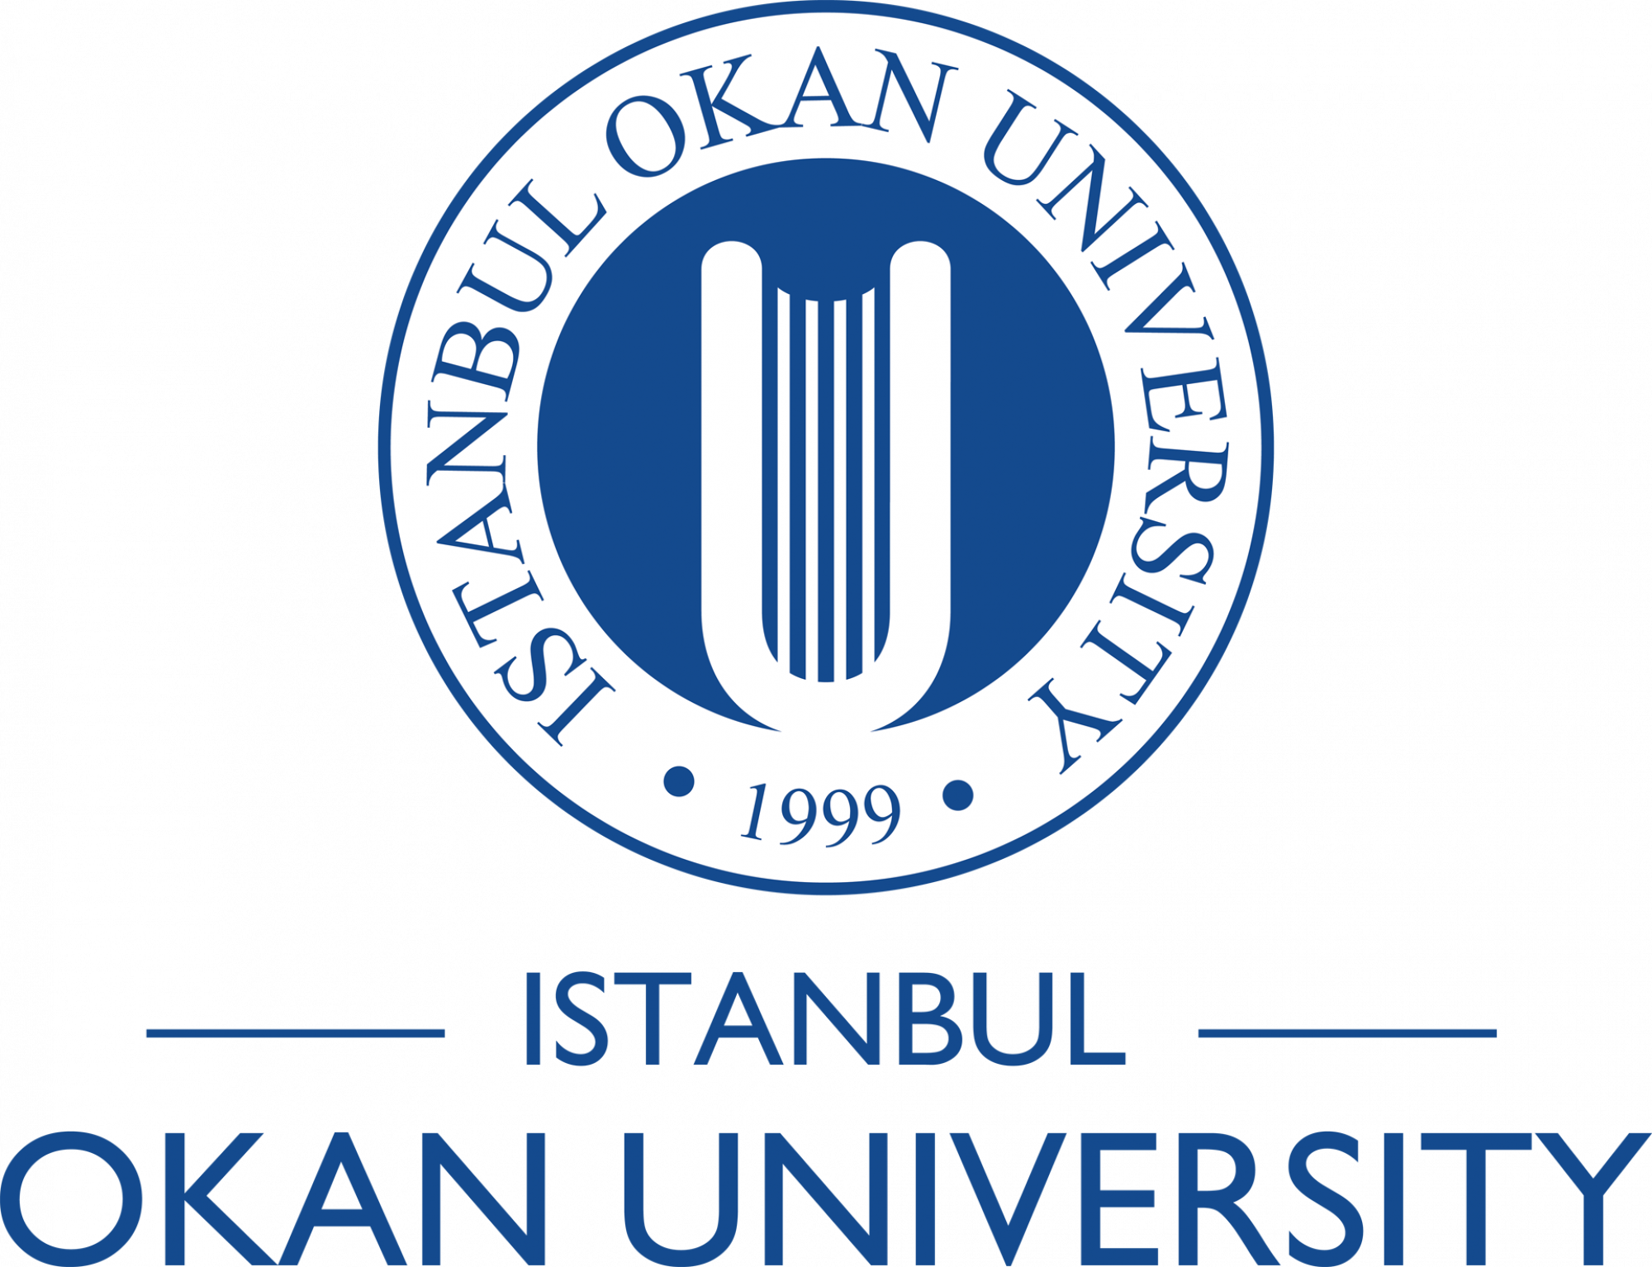Y
The duration of the Master’s Degree Program with Thesis is four semesters, regardless of whether the student registers for courses in each semester. The program must be completed within a maximum of six semesters.

Students are required to complete the courses specified in the curriculum within a minimum of two semesters and a maximum of four semesters.

Students are required to complete their coursework and prepare their thesis within this period. Failure to do so will result in dismissal from the University.

