

GRADUATION PROJECT WRITING GUIDELINES

GRADUATE SCHOOL

JUNE 2026

TABLE OF CONTENTS
PREFACE 1
1. FORMATTING AND LAYOUT 3
1.1 Margins 3
1.2 Font Type and Size 4
1.3 Line Spacing 4
1.4 Text Alignment and Centering 5
1.5 Page Numbers 6
1.6 Setting Indentation 6
1.7 Headings 7
1.8 Numbering 9
2. TABLES, FIGURES, AND FOOTNOTES 10
2.1 Tables and Figures 10
2.2 Visual Elements 12
2.3 Abbreviations and Symbols 12
2.4 Equations 13
2.5 Footnotes 13
3. PROJECT SECTIONS 14
3.1 Order of Project Sections 14
3.2 Preliminary Pages 14
3.2.1 Title Page 14
3.2.2 Declaration 15
3.2.3 Abstract and Keywords 15
3.2.4 Acknowledgements 16
3.2.5 Table of Contents 16
3.2.6 List of Tables, List of Figures, List of Abbreviations and List of Symbols 17
3.3 Main Text 17
3.3.1 Writing Style 17
3.3.2 Chapter Structure 18
3.3.3 Quotations 18
3.3.4 Points to Consider in Writing 19
3.4 References 19
3.5 Appendices 20
4. BINDING OF PROJECT 21
4.1 Printing 21
4.2 Project Cover Specifications 21
4.2.1 Spine Format 21
4.2.2 Cover Layout 21
4.2.3 Binding and Color Code 22
4.2.4 Text on the Cover and Spine 22
APPENDICES 23
APPENDIX A. SAMPLE PROJECT SPINE 24
APPENDIX B. SAMPLE PROJECT BOUND COVER PAGE 25
APPENDIX C. SAMPLE PROJECT INNER COVER PAGE 26
APPENDIX D. SAMPLE TITLE PAGE 27

* This “Table of Contents” of the Guide refers to the page numbering of the Graduation Project Writing Guide. It is included to facilitate easy access to the information in the guide. The “Table of Contents” in students’ projects is different. Therefore, students are advised to carefully review both the Guide and the relevant Graduation Project Template.

PREFACE
This Graduation Project Writing Guide of the Graduate School at Istanbul Okan University has been prepared to ensure consistency in quality and formal standards in the planning, preparation, writing, and printing of non-thesis master’s graduation projects. Students who will prepare a non-thesis master’s graduation project are required to comply with the principles, rules, and standards specified in this Guide. In case of non-compliance with these requirements, the Institute reserves the right not to initiate graduation procedures or to suspend ongoing procedures, even if all courses have been successfully completed. In this Guide, the term “Graduation Project” will be used for non-thesis master’s studies.
The Guide is based on the most recent edition of the American Psychological Association (APA) citation style. However, some rules (e.g., referencing format) may vary depending on the academic preferences of different disciplines and fields of study.
In order to ensure compliance with the rules and standards in Project writing and to avoid delays in graduation, it is strongly recommended that this Guide be carefully reviewed and that the discipline-specific Graduation Project Templates be used.
Along with the Guide, a Graduation Project Template and a Graduation Project Format Checklist have been prepared to support students in maintaining compliance with the required standards. Before submission to the Graduate School, the capstone Project should be reviewed by both the student and the Project supervisor in terms of formal requirements based on the checklist.
Even if previously approved Graduation Projects have been successfully completed, they should not be used as templates. A previously written Graduation Project may differ from the current version of the rules and standards set out in this Guide. The Guide, Graduation Project Template, and Graduation Project Format Checklist available on the Institute’s website must be used as the official reference.
For any issues not covered in the Guide or the Graduation Project Template, or in case of uncertainty, students are advised to first consult their supervisor, then the head of their department, or if necessary, the Directorate of the Graduate School.
Directorate of the Graduate School
1. FORMATTING AND LAYOUT

In this section, formatting rules for the different components of the Graduation Project text (main text, tables, figures, footnotes, etc.) are presented.

1.1 Margins
Across all Graduation Projects, page margins must be set as follows: 3.5 cm on the left (the left margin is wider than the right margin to allow for binding), 2.5 cm on the right, 3.5 cm at the top, and 2.5 cm at the bottom. The header and footer margins must be 1.25 cm. For horizontal (landscape) pages, the top margin must also be set to 3.5 cm to ensure proper binding alignment.
When starting to write the capstone Project, it is recommended to adjust the page margins first. All content, including headings, main text, tables, figures, and page numbers, must remain within the specified page margins. No content is allowed to extend beyond the defined text boundaries.
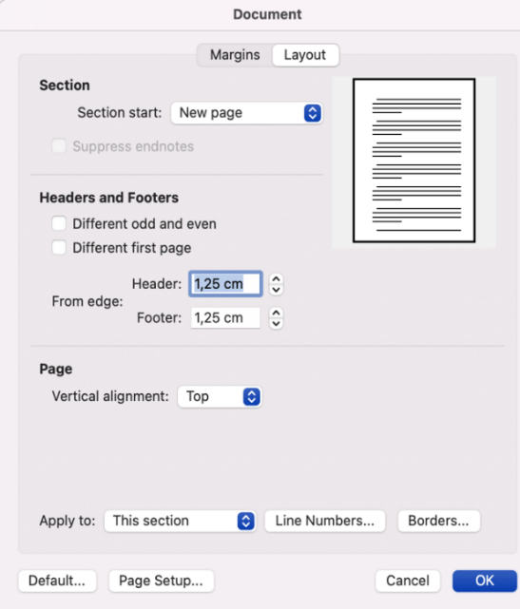
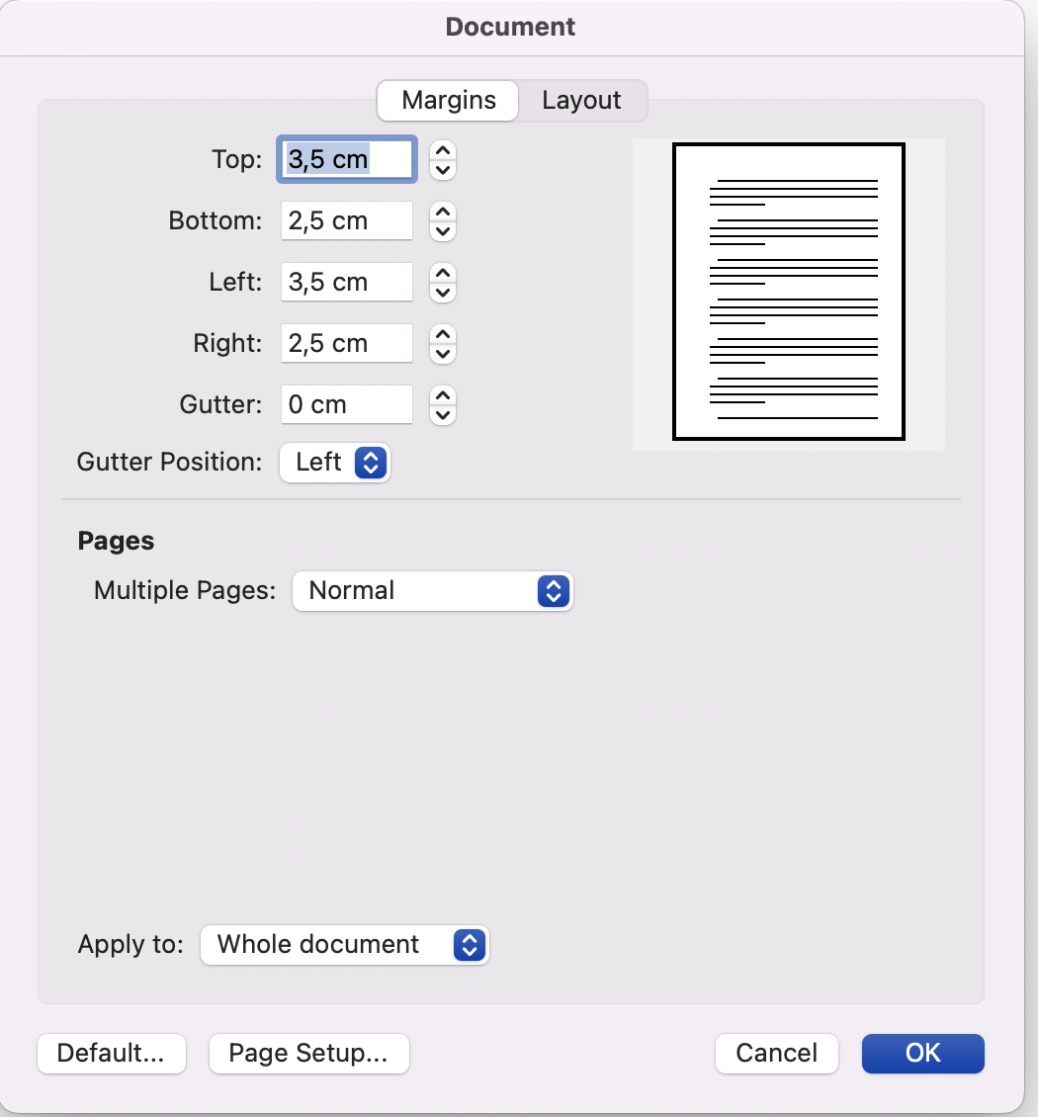
Figure 1.1 Setting Page Margins in Microsoft Word
Note: The interface may vary across different versions.

Font Type and Size
Times New Roman must be used throughout the entire Graduation Project. It must be ensured that no other font is used in any part of the Project. For expressions requiring emphasis and for foreign terms, bold and/or italic formatting may be used.
The font sizes to be used for different types of text in the Project (such as headings, main text, notes, footnotes, tables, and figures) should be determined in accordance with Table 1.1.

Line Spacing
Line spacing for different types of text in the Project should be determined in accordance with Table 1.1. No additional line spacing should be left between paragraphs.
Table 1.1 Font Sizes, Line Spacing, and Alignment for Text Types
Text Type | Font Size | Line Spacing / Alignment
Project Title | 15 pt | Single spacing, centered
First-Level Headings | 12 pt  12 pt  12 pt  12 pt  12 pt  12 pt | Double spacing, centered; a 12 pt spacing should be left after first-level headings.Double spacing, justified; a 12 pt spacing should be left before second-level and lower-level headings. If a heading appears at the top of a new page, no 12 pt spacing should be added above it.
Second-Level Headings | 12 pt  12 pt  12 pt  12 pt  12 pt  12 pt
Third-Level Headings | 12 pt  12 pt  12 pt  12 pt  12 pt  12 pt
Fourth-Level Headings  Fifth-Level Headings  Sixth-Level and Higher Headings | 12 pt  12 pt  12 pt  12 pt  12 pt  12 pt
Declaration | 12 pt | Double spacing; justified alignment.
Table of Contents | 12 pt | 1.5 line spacing; justified alignment.
List of Tables, List of Figures | 12 pt | 1.5 line spacing; justified alignment.
List of Abbreviations and Symbols | 12 pt | 1.5 line spacing; justified alignment.
Acknowledgements Text, Abstract Text, Abstract Text, | 12 pt | Double spacing; justified alignment.
Main Text | 12 pt | 1.5 line spacing
References | 12 pt | Double spacing; justified alignment.
Table Titles and Figure Titles | 12 pt | If there are multiple lines, use double spacing and justified alignment. A 12 pt spacing should be left before the table or figure title and after the table or figure. If there is a note within the table or figure, a 12 pt spacing should be left after the note.
Footnotes, Figure Notes, Table Notes | 10 pt | Single spacing, justified alignment.
Table Content | It may be between 8–12 pt. However, consistency must be maintained throughout the entire project. | It may be single, 1.5, or double spaced; however, the same spacing must be used consistently in all tables throughout the project. Table cells may be centered, right-aligned, or left-aligned as needed. All tables in the project must be consistent in terms of alignment style.
Figure Content | It may be between 8–12 pt. However, consistency must be maintained throughout the entire project. | It may be single, 1.5, or double spaced; however, the same spacing must be used consistently for all figures throughout the project.
Equations | 12 pt | If there are multiple equations, single spacing should be used. A 12 pt spacing should be left before and after the equation(s).

1.4 Text Alignment and Centering
Alignment rules and standards for different types of text in the Project should be determined in accordance with Table 1.2. To ensure proper alignment after binding, text should be aligned within the text margins rather than to the physical page edges.
All section headings (e.g., DECLARATION, ABSTRACT, ACKNOWLEDGEMENTS, TABLE OF CONTENTS, LIST OF TABLES, LIST OF FIGURES, LIST OF ABBREVIATIONS AND SYMBOLS, CHAPTER HEADINGS, REFERENCES, APPENDICES, APPENDIX A, etc.) must be centered.
Declaration, Abstract, and Abstract texts should be justified, written as a single paragraph, and without first-line indentation.
Acknowledgements text, main text, References, and the content of Appendices must be justified.
Table and figure titles, notes, and footnotes must be justified.
Tables and figures should be centered. Table cells should preferably be centered as well. Alignment must be consistent throughout the entire Project.

1.5 Page Numbers
Page numbers must be placed at the bottom center of the page. All page numbers must be in Times New Roman, 12 pt. The same font type and size must be used consistently for all page numbers. No symbols such as parentheses, dashes, or similar marks may be placed before or after page numbers.
Preliminary pages are numbered using lowercase Roman numerals (iv, v, vi, …), while the main text section is numbered consecutively using Arabic numerals (1, 2, 3, …) throughout the entire Project.
The bound external cover is not numbered. Page numbering starts from the inner cover page. However, the inner cover and title page are not displayed with page numbers. Page numbering begins to appear on the third preliminary page, which is the Declaration page, and starts with the lowercase Roman numeral “iii”.
The first page of the main text, “Introduction,” starts with page number “1,” and page numbering continues consecutively using this numbering style through to the final page of the Project, including the Appendices.

Settin Indentation
The first lines of all paragraphs (except for Declaration, Abstract, and Abstract (English)) must have a 1-tab (1.25 cm) indentation throughout the entire Project.
Indentation of headings should be determined in accordance with Table 1.2.
In APA reference style, a hanging indent is used in the bibliography. In a hanging indent format, the first line of each reference is not indented, while the subsequent lines of the same reference are indented by 1.25 cm. For disciplines such as law, medicine, health sciences, pharmacy, engineering, and natural sciences that use different referencing styles, please refer to the relevant Graduation Project Template.

Headings
Formatting rules for heading levels (alignment, justification, font type, font size, numbering, and indentation settings) should be determined in accordance with Table 1.2.
A single line of text should not appear at the end of a page. Headings appearing at the end of a page must be followed by at least two lines of text; otherwise, they should be moved to a new page. In such cases, a single line of text or the continuation of the heading must be placed at the top of the following page.

Table 1.2 Heading Levels, Formatting, and Numbering
Headings and Formatting
FIRST-LEVEL HEADINGS
First-level headings are written as shown in the example, in 12 pt, centered, bold, and in uppercase letters. A 12 pt spacing is left between the heading and the text.
1.1 Second-Level Headings
Second-level headings are written as shown in this paragraph, in 12 pt, justified, double spaced, bold, and with each word’s initial letter capitalized and the remaining letters in lowercase. Conjunctions such as “and,” “or,” and “with” are written in lowercase. A 12 pt spacing is left before the heading. No additional spacing is left after the heading. The text begins on a new paragraph below, as shown here.
1.1.1 Third-Level Headıngs
Third-level headings are written as shown in this paragraph, in 12 pt, justified, double spaced, bold, and italic, with each word’s initial letter capitalized and the remaining letters in lowercase. Conjunctions such as “and,” “or,” and “with” are written in lowercase. A 12 pt spacing is left before the heading. No additional spacing is left after the heading. The text begins on a new paragraph below, as shown here.
1.1.1.1 Fourth-Level Headings
Fourth-level headings are written as shown in this paragraph, with a 1-tab indentation, in 12 pt, justified, double spaced, bold, and with each word’s initial letter capitalized and the remaining letters in lowercase. Conjunctions such as “and,” “or,” and “with” are written in lowercase. A 12 pt spacing is left before the heading. No additional spacing is left after the heading. The text begins on a new paragraph below, as shown here.
1.1.1.1.1 Fifth-Level Headings
Fifth-level headings are written as shown in this paragraph, with a 1-tab indentation, in 12 pt, justified, double spaced, bold, and italic, with each word’s initial letter capitalized and the remaining letters in lowercase. Conjunctions such as “and,” “or,” and “with” are written in lowercase. A 12 pt spacing is left before the heading. No additional spacing is left after the heading. The text begins on a new paragraph below, as shown here..
1.1.1.1.1.1 Sixth-Level And Higher Headings
Sixth-level and higher headings are written as shown in this paragraph, with a 2-tab indentation, in 12 pt, justified, double spaced, bold, and with each word’s initial letter capitalized and the remaining letters in lowercase. Conjunctions such as “and,” “or,” and “with” are written in lowercase. A 12 pt spacing is left before the heading. No additional spacing is left after the heading. The text begins on a new paragraph below, as shown here.

Note: Sixth-level and higher headings are defined only for Graduation Projects in the field/discipline of Law. In other fields/disciplines, the heading level must not exceed Level 5.

Numbering
Main Chapter Headings are numbered using Arabic numerals (1, 2, 3, etc.), except for the Introduction section.
Footnotes are numbered consecutively using Arabic numerals (1, 2, 3, etc.) throughout the entire Project. Footnote numbering does not restart in each new chapter.
A period (full stop) is not placed after the final digit of headings, tables, and figures (e.g., Table 2.1, Figure 2.1). For the numbering rules of tables and figures, Section 2.1 (Tables and Figures) of this Guide should be consulted.
For the numbering of equations, Section 2.4 (Equations) of this Guide should be consulted.

2. TABLES, FIGURES, AND FOOTNOTES

Tables and Figures
Tables and figures should be used when they can more effectively present an idea or data that is difficult to express in text. Unnecessary tables and figures should be avoided.
It is recommended to use the table function in Microsoft Word to create tables. Copying and pasting a table from another program may require formatting adjustments. Figures can be created using different software such as Excel or SPSS. Lines, symbols, numbers, and text within figures should be prepared using tools such as a laser printer, rapidograph, or Letraset transfer lettering. These elements must be clearly visible and legible to the naked eye. When inserting a figure or visual into the text, the image resolution must be 300 dpi (dots per inch). For appropriate table and figure formats designed for different types of analyses, the latest edition of the APA style guide may be used. For different academic disciplines, it is recommended to consult the supervisor and/or the head of the department
The titles of tables and figures in the List of Tables and List of Figures must be identical to those used in the main text. In the lists, page numbers corresponding to the last line of each entry should be right-aligned. In tables and figures that span more than one page in the main text, only the page number of the first appearance of the relevant table or figure should be indicated.
Tables and figures must be referenced within the text (e.g., Table 2.1). Tables and figures should preferably be placed immediately after the paragraph in which they are first cited. If a table or figure cannot be placed after the paragraph of its first citation, it should be positioned as close as possible to the relevant text. In such cases, the Guide recommends placing it on the following page.
A table or figure is not placed immediately after its title; there must be text between the title and the table or figure. A 12 pt spacing must be left before the table or figure title and after the table or figure in relation to the main text. If a note is included for a table or figure, a 12 pt spacing must be left after the note.
Tables and figures are numbered consecutively within each main chapter (e.g., Table 1.1, Table 1.2, Figure 2.1, Figure 2.2, etc.). Table and figure numbers must be in bold. No period is placed after the final digit. If a table or figure contains multiple elements, each element is labeled as A, B, C, etc., and each is explained separately. However, only a single number is assigned to the table or figure.
The table title is written above the table, and a 6 pt spacing is left between the last line of the table title and the top edge of the table. The figure title is written below the figure, and a 6 pt spacing is left between the figure title and the bottom edge of the figure. Table and figure titles are written in 12 pt, italic, justified, with each word’s initial letter capitalized and the remaining letters in lowercase, and no period at the end. Unlike table and figure numbers, titles are not bold. Table and figure numbers and their titles continue on the same line. If a second line is required in the title, the lines are double spaced. Line spacing within tables may be single, 1.5, or double depending on the case. However, except for very specific cases, the line spacing within tables should remain consistent throughout the entire Project.
Not every table or figure requires a note. If a note is included below a table or figure, a 6 pt spacing must be left between the table/figure title and the note, and the note must be written in 10 pt, italic, single line spacing, and must end with a period. Notes that do not fit on a single line should continue on the next line aligned with the first line of the note.
Font sizes in tables and figures should preferably be 12 pt. However, for tables or figures that cannot fit on a single page, a font size between 8–12 pt may be used. In such cases, the font size should remain consistent throughout the Project except in special cases. If a table still does not fit on a page despite using a smaller font size, it should be split at an appropriate point and presented in page-sized sections. In this case, the continuation of the table should be presented on the following page with the same table number and the same title; however, the word “(Continued)” should be added in parentheses after the table number..
Only the first letter of the first word should be capitalized in table and figure text; all other letters should be lowercase. For data presentation in table columns and rows, cell alignment, and other formatting details, the most recent edition of the APA style guide should be followed.

2.2 Visual Elements
Visual elements include materials such as images, photographs, and drawings. All visual elements are subject to figure formatting rules and are included in the List of Figures..
Written permission must be obtained to use any copyrighted material. The written permission obtained must be acknowledged on the Acknowledgements page. A reference to the cited material must be provided in the note section below the relevant item, in accordance with citation rules.
To ensure quality and clarity in visual elements, the resolution of visual materials must be 300 dpi (dots per inch). Visuals may be in color or black and white.
If any visual material includes a photograph or information that allows a person or persons to be identified, written consent must be obtained from the individuals concerned in accordance with the Personal Data Protection Law. Photographs of patients or subjects may be used in a way that does not reveal their identity, for example by masking the eyes. Photographs to be attached to Project pages should be printed on thin photo paper in order to prevent any possible bulk between the pages of the Project.
2.3 Abbreviations and Symbols
Abbreviations and symbols used in the Project must be listed in alphabetical order. An abbreviation must be defined in parentheses the first time it appears in the text and only once. In abbreviations formed from the initial letters of multiple words, no periods should be used between letters (e.g., TÜBİTAK, WHO). Turkish equivalents of terms must be used in abbreviations. However, established abbreviations in foreign languages may be used as they are (e.g., AIDS, NATO). Non-terminological abbreviations (e.g., “bkz.”, “vb.”) must end with a period. For measurement units, abbreviations in accordance with the International System of Units (https://www.bipm.org/en/measurement-units/) must be used (e.g., g, L). No period should be placed after unit symbols.

2.4 Equations
Equations should be written on a separate line, centered, and in italics, as shown in the example. The symbols used in equations must be consistent with those listed in the List of Symbols. The number of an equation must be shown on the right side of the same line in parentheses. The word “Equation” must not appear before the equation number. Equations are numbered separately for each chapter, as shown in the example. If necessary, sub-expressions of the same equation may be numbered as (2.1a), (2.1b), etc. However, when cited in the text, they must be referenced in the form “Equation 2.1.” A 12 pt spacing must be left before and after each equation between the main text and the equation. Multiple equations or expressions may be included in the main text or appendices.
$A=πr^{2}$ (2.1)

2.5 Footnotes
Footnotes are numbered consecutively in the order they appear in the text using superscript numbers. Footnotes must be inserted using the footnote function in Microsoft Word. Footnote text should be written in 10 pt font with single line spacing. Explanatory footnotes for tables and figures should be placed directly below the table or figure (if any), following the note section, and written in 10 pt font with single line spacing.
In the field/discipline of Law, the Chicago footnote style is used. The relevant Graduation Project Template should be used for this purpose. When necessary, it is recommended to consult the supervisor and/or the head of the relevant department.

3. PROJECT SECTIONS
3.1 Order of Project Sections

The Graduation Project consists of three main sections: preliminary pages, main text, and references. The Project sections shown in Table 3.1 must be listed in the required order of the Project. Attention should be paid to whether each section is mandatory or optional.
Table 3.1 Project Sections and Order
Preliminary Pages Section | External Cover | Required for printed copies
Preliminary Pages Section | Inner Cover Page | Required (identical to the external cover)
Preliminary Pages Section | Title Page | Required
Preliminary Pages Section | Declaration | Required
Preliminary Pages Section | Abstract  Keywords (minimum 3, maximum 5) | Required  Required
Preliminary Pages Section | Abstract (English) + Keywords (minimum 3, maximum 5) | Required  Required
Preliminary Pages Section | Acknowledgements Page | Optional
Preliminary Pages Section | Table of Contents | Required
Preliminary Pages Section | List of Tables | Required if tables are included
Preliminary Pages Section | List of Figures | Required if figures are included
Preliminary Pages Section | List of Abbreviations | Required if abbreviations are included
Preliminary Pages Section | List of Symbols | Required if symbols are included
Main Body Section | Main Text | Required
Main Body Section | Footnotes, Tables, Figures | To be evaluated according to the content
References Section | References | Required
References Section | Appendices | To be included as needed based on the content

3.2 Preliminary Pages

3.2.1 Title Page
The following elements must appear on the title page in the order specified. All elements must be written in uppercase letters, bold, and centered. The Graduation Project title must be in 15 pt font, while all other headings must be in 12 pt font. The page number must not be displayed on the title page. For the layout of the title page, see the Appendix.
The Guide recommends that the Project Title should not exceed 10 words.
- University Logo
- Institute Name (For Projects written in Turkish, this should be “Lisansüstü Eğitim Enstitüsü”.)
- Department Name
- Program/Division Name (if applicable)
- Graduation Project Title
- Student’s Full Name and Surname
- Student Number
- Supervisor’s academic title, name, and surname. In Projects written in Turkish, abbreviated academic titles are used (e.g., Prof. Dr., Doç. Dr., Dr. Öğr. Üyesi).
- Year

3.2.2 Declaration
The Declaration Page is mandatory and must be signed by the author of the Project using a blue-ink pen. This section must include the heading “DECLARATION”. The declaration text is a standard text provided in the Graduation Project Template. The page containing the declaration text is numbered with the Roman numeral “iii”.

3.2.3 Abstract / Summary and Keywords
The Abstract is written to provide readers with a concise understanding of the project's purpose, scope, methodology, and findings. It should accurately reflect the study conducted and highlight its original contribution. Subheadings such as “Purpose”, “Method”, and “Conclusion” should not be used in the abstract.
The Turkish and English abstract pages must appear consecutively, with the Turkish abstract first, followed by the English abstract. The headings “ÖZET” and “ABSTRACT” must be written in uppercase letters, bold, and centered. As with all section headings, a 12 pt spacing must be left after the headings “ÖZET” and “ABSTRACT”. Both the Turkish and English abstract texts must be written as a single paragraph, without first-line indentation, and with double line spacing.
The abstract should not exceed one page and should not include references or data unless absolutely necessary.
At the end of the Turkish and English abstract pages, the bold headings “Anahtar Sözcükler” and “Keywords” should be written with each word’s initial letter capitalized. On the same line, key words or phrases related to the Project (minimum 3, maximum 5) should be listed in alphabetical order, separated by commas, and written in lowercase letters.

3.2.4 Acknowledgements Page
The Acknowledgements Page is optional. However, if there are individuals or institutions that contributed to the conduct and preparation of the Project, and/or if copyrighted material is used with permission, it is recommended to acknowledge the supporting parties. The Acknowledgements Page also includes expressions of gratitude to those who supported the student during the preparation of the Project. It should be written in simple, clear, and concise language and, if possible, should not exceed one page.
The heading “ACKNOWLEDGEMENTS” must be written in bold and centered between the text margins. The acknowledgements text should be double spaced. A 12 pt spacing must be left between the heading and the text.
The Acknowledgements Page may consist of more than one paragraph. The first line of each paragraph must be indented by 1.25 cm.
No information such as name and surname, Project date, city name, etc. should be written at the end of the Acknowledgements Page.

3.2.5 Table of Contents
In the Table of Contents, starting from the “Abstract” page in the preliminary pages section, all chapter titles and subheadings in the main text, as well as the reference section consisting of the References and Appendices, must be listed completely and in the correct order of the Project.
The heading “TABLE OF CONTENTS” must be centered between the text margins. A 12 pt spacing must be left between the heading and the list. The content of the Table of Contents must be written in 12 pt font, 1.5 line spacing, and justified alignment.
In the Table of Contents, all elements of the Project must be listed exactly as they appear, without any modification, in the order in which they occur, along with their page numbers. Headings that do not fit on a single line must continue on the next line aligned with the first line.
Although some headings in the Project may be italic and/or bold, no headings in the Table of Contents are formatted as italic and/or bold. It is recommended to use the Table of Contents function in Microsoft Word to prepare the Table of Contents. The “Table of Contents” page is formatted in the Graduation Project Template.

3.2.6 List of Tables, List of Figures, List of Abbreviations, and List of Symbols
Tables, figures, visuals, abbreviations, and symbols included in the text must be listed on separate pages following the Table of Contents, in the order specified in the Guide. The section headings of these lists must be centered, written in uppercase letters, bold, and in 12 pt font (“LIST OF TABLES”, “LIST OF FIGURES”, “LIST OF ABBREVIATIONS”, “LIST OF SYMBOLS”). A 12 pt spacing must be left between the headings and the lists. Table and figure numbers and titles must be written exactly as they appear in the text (e.g., Figure 1.1 Figure Title, Table 4.2 Table Title). Abbreviations and symbols must be listed in alphabetical order.

3.3 Main Text
3.3.1 Writing Style

The Project should be written in a simple, clear, and understandable language, in accordance with Turkish grammar rules, preferably using passive constructions that refer to the third person (e.g., “was conducted,” “was observed”). The use of foreign words that have not been adapted into Turkish should be avoided. However, for foreign terms or concepts that do not have an exact Turkish equivalent, the original foreign term should be provided in parentheses at its first occurrence in the text after the Turkish equivalent. The Turkish Language Association (Türk Dil Kurumu) Spelling Guide must be taken as the basis for writing.
In determining the chapters and subchapters of the Project, unnecessary detail should be avoided, and logical coherence should be maintained.
3.3.2 Chapter Structure

The main text is divided into multiple main chapters. Each main chapter of the Project begins on a new page. Except for the “Introduction” section, all main chapters are numbered consecutively using Arabic numerals (1, 2, 3, etc.) followed by the title. The titles of the main chapters are centered, written in uppercase letters, and in bold.
Each main chapter begins on a new page. Subsections of the main text may vary depending on the academic field/discipline. It is strongly recommended to consult the supervisor regarding which main chapters and subheadings should be included in the Project structure.
3.3.3 Quotations

If a section consisting of more than one sentence taken from another source is to be quoted exactly within the text, it should be written as a separate paragraph after leaving one blank line from the last line of the main text, starting from a new line, enclosed in quotation marks (“ ”), and in italics. The quoted text must be formatted as a block with 1.25 cm indentation on both sides of the main text. When returning to the main text after the quotation, one line must again be left blank.
Direct quotations of fewer than 40 words must be shown within the paragraph using double quotation marks.
Direct quotations of 40 words or more must be presented as a separate paragraph with 1 cm indentation on both the left and right margins and with justified alignment.
References from which quotations are taken must be cited in accordance with the rules specified in this Guide.
3.3.4 Points to Consider in Writing
The first line of a paragraph should not appear as the last line of a page, and the last line of a paragraph should not appear as the first line of a page. A subheading appearing at the end of a page must be followed by at least two lines of text, otherwise the subheading should be placed on a new page.
Except for institutional abbreviations and dates, lines in the text must not begin with abbreviations, symbols, or numbers.
Numbers up to 10 in the text must be written in words, while larger numbers must be written in digits. Numbers that appear at the beginning of a sentence must always be written in words, regardless of their value.
According to the Turkish Language Association, numbers with four or more digits are written in groups of three from the end, with periods placed between these groups (e.g., 4.567; 326.197; 49.750.812; 28.434.250.310.500, etc.).
Fractions in numbers are separated by a comma (e.g., 15,2; 5,26, etc.). In Projects written in programs where education is conducted in a foreign language, in accordance with APA referencing style, only a period (.) is used in decimal notation. When writing large numbers, digits are grouped in threes starting from the last digit, and these groups are separated by commas.

3.4 References
The References section is a list of all sources cited and referenced within the Project. Every source used in the text must be included in the “REFERENCES” section. Likewise, every source listed in the “REFERENCES” section must be cited within the text. The author of the Project is responsible for providing complete and accurate source information.
The current version of the referencing style accepted in the registered field/discipline must be used. Table 3.2 should be taken into consideration in this regard. It is recommended to consult the supervisor and/or the head of the department for different academic fields/disciplines.
Table 3.2 Reference Styles by Academic Field / Discipline
Academic Fields / Disciplines | Reference Styles
All academic fields/disciplines except Engineering and Natural Sciences, Dentistry, Pharmacy, Medicine and Health Sciences, and Law. | APA
Law Discipline / Field | Chicago
Engineering and Natural Sciences, Dentistry, Pharmacy, Medicine and Health Sciences Fields / Disciplines | Vancouver

3.5 Appendices
Information that would disrupt the flow of the main text if included in the main body of the Project (such as scales, raw data tables, forms, consent documents, ethics committee approval, etc.), as well as lengthy explanations that would otherwise be given as footnotes, may be included at the end of the Project under the heading “APPENDIX”.
If more than one appendix is included, each must be presented on a separate page and labeled with a letter and a title (e.g., APPENDIX A. TITLE, APPENDIX B. TITLE). As with other first-level headings, appendix titles must be centered between the text margins. Each appendix must be listed separately under the general heading “APPENDICES” in the Table of Contents, together with its title. A separate “List of Appendices” page, like the List of Tables, is not prepared.

4. BINDING OF THE PROJECT

Printing
One bound copy must be submitted to the Directorate of the Graduate School.
It is recommended that the Gaduation Project be converted to “PDF” format before printing. The Project must be printed on uniform white A4-sized paper (210×297 mm / 80 g/m²). To maintain print quality, a laser printer should be used. Printing must be done on one side of the paper using standard black ink. However, colored materials (e.g., figures, images, etc.) must be printed in color as they appear in the text. The resolution of visual materials must be 300 dpi..

The Project must not contain any handwritten or typewritten corrections, erasures, or scratch-outs.

4.2 Properties of the Project Cover

4.2.1 Spine Format
The spine of the binding includes the student’s name and surname, the Graduation Project title, and the year. For the spine format, see the Appendix.

4.2.2 Cover Layout
The same cover page must be used for both the bound cover and the inner cover of the Project. The only difference is that the student number and the supervisor’s academic title, name, and surname are also included on the inner cover. Page numbering begins with the inner cover page; however, the page number is not shown on this page.
The cover page must include the University logo, the Graduation Project title, the project level information (NON-THESIS MASTER’S GRADUATION PROJECT), the student’s full legal name and surname as stated in official documents, the student number (required only for the inner cover), the supervisor’s academic title, name and surname (required only for the inner cover), and the year.
On the Cover Page, the Graduation Project title is written in 15 pt font, while all other lines are written in 12 pt font. All text on the cover page must be in uppercase letters, Times New Roman font, bold, and centered. For the layout of the Cover Page, see the Appendices.

4.2.3 Binding and Color Code
The binding color for non-thesis master’s projects must be white coated cardboard. Before binding, it is recommended to review sample projects at the Graduate Education Institute or the University Library to obtain information about the material and texture.

4.2.4 Text on the Cover and Spine
All letters on the cover and spine must be printed in uppercase, bold, and black.

APPENDICES

APPENDIX A. SAMPLE SPINE

FULL NAME PROJECT TITLE YEAR
All text on the spine must be written in 12 pt, Times New Roman, bold, and uppercase.
However, if it does not fit on the spine, a font size between 10–12 pt may be used.
If there is more than one line, single line spacing must be used.

APPENDIX B. SAMPLE COVER PAGE


PROJECT TITLE
NON-THESIS MASTER’S GRADUATION PROJECT

STUDENT’S FULL NAME

YEAR

The year is placed 24 cm from the top edge of the page
The student’s name and surname are placed 18.5 cm from the top edge of the page
The project title is placed 13.5 cm from the top edge of the page
A double line spacing is left between the thesis title and the project level
The logo starts 4.5 cm from the top edge of the page.

APPENDIX C. SAMPLE INNER COVER PAGE

PROJECT TITLE
NON-THESIS MASTER’S GRADUATION PROJECT

STUDENT’S FULL NAME
STUDENT NUMBER

SUPERVISOR’S TITLE AND FULL NAME

YEAR

The logo starts 4.5 cm from the top edge of the page

The project title is placed 13.5 cm from the top edge of the page

A double line spacing is left between the project title and the project level

The student’s full name are placed 18.5 cm from the top edge of the page

A single line spacing is left between the student’s full name and student number

The supervisor’s information is placed 21 cm from the top edge of the page

The year is placed 24 cm from the top edge of the page

APPENDIX D. SAMPLE TITLE PAGE
The logo starts 4.5 cm from the top edge of the page
GRADUATE SCHOOL
FULL NAME OF DEPARTMENT
FULL NAME OF PROGRAM (IF ANY)

PROJECT TITLE
NON-THESIS MASTER’S GRADUATION PROJECT

STUDENT’S FULL NAME
STUDENT NUMBER

SUPERVISOR’S TITLE AND FULL NAME

YEAR

The institute name is placed 10.5 cm from the top edge of the page

A single line spacing is left between the Institute, Department, and Program (if any) names

The project title is placed 15 cm from the top edge of the page

A double line spacing is left between the project title and the project level

The student’s full name are placed 19 cm from the top edge of the page.

A single line spacing is left between the student’s full name and the student number

The supervisor’s information is placed 21 cm from the top edge of the page

The year is placed 25.5 cm from the top edge of the page

Sixth-Level and Higher Headings; defined only for projects in the field/discipline of Law. In other fields/disciplines, the heading level must not exceed Level 5.

