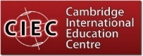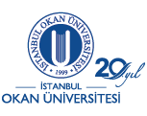

Istanbul Okan University Launches International Foundation Course in Business in Turkey

Istanbul Okan University is delighted to announce that they will be offering an International Foundation Course in Business in conjunction with Cambridge International Education Centre with effect from September 2019 at their modern state-of-the art campus in Istanbul.

About Istanbul Okan University
Istanbul Okan University, one of the most eminent and distinguished foundation universities in Turkey, is home to a diverse undergraduate and graduate body of over 26,000 students from 43 different countries, with more than 138 undergraduate and graduate programmes. The University comprises six Faculties, two Applied Sciences Schools and three Graduate Schools. The university also offers a variety of two year Associate Degree programmes that correspond to vocational opportunities in high demand.
Istanbul Okan University strives continuously to further the development of knowledge both nationally and internationally with its high quality student-centred education, accredited programs and its research centres. True to its motto, “Leader in University-Business Cooperation”, Istanbul Okan University effectively combines theory and practice by employing distinguished academic staff and inviting expert professionals to lecture the students to prepare them for successful careers. In close cooperation with various business sectors, the university has developed curricula and internship programs for its students to enhance their employability skills.
Istanbul Okan University is located in Istanbul, the only city that spans the two continents, Europe and Asia. Besides the main campus on the Asian part of Istanbul, with its modern Faculty buildings, residence halls and social facilities, Istanbul Okan University has three other campuses in central locations on both European and Asian sides of the city.

About Cambridge International Education Centre
Cambridge International Education Centre Ltd (CIEC) comprises a substantial group of distinguished academic and professional practitioners with national and international experience covering a wide range of subject areas and who have come together to create a unique international network offering courses and qualifications across the globe.
CIEC specialises in Business, Management, Information Technology, Law and English Language education, alongside its expertise in Aviation related programmes. Members of CIEC have extensive experience in senior management and leadership in university education in the UK and internationally, as well as consultancy and research with bodies such as the OECD and major multinational companies. CIEC also has expertise in course validation, quality assurance, external examining and developing learning materials for UK and international universities.
Colleagues of CIEC have published major textbooks for Pearson, the world’s largest educational publisher, in many languages, in a wide range of economics, business, management and English subject areas.
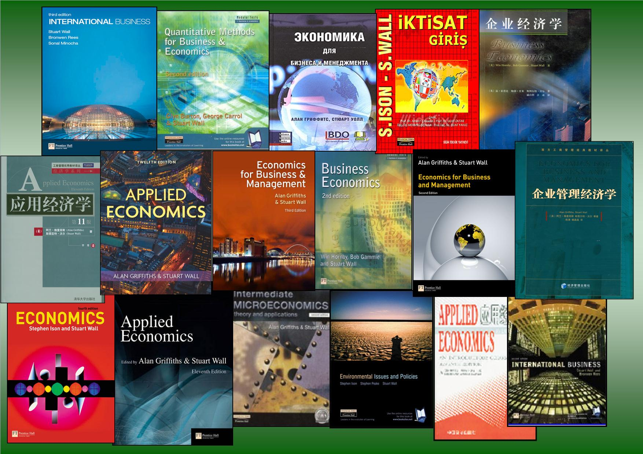

Course Rationale
The Istanbul Okan University/CIEC International Foundation Course is specifically designed for international students –
- To prepare and equip students who intend to study Business, Management and related subjects at degree level in courses delivered and assessed in the English medium;
- To raise English Language proficiency levels to equip students to succeed in high ranking UK and international Universities;
- To provide a strong basis of knowledge and understanding of key business areas essential to success at University;
- To equip students to be effective independent learners, able to access and use effectively a wide range of sources of information and data

Unique Selling Points (USPs)
The course has a number of USPs including the following –
- Progression Pathways to UK and International Universities
- Delivery by Professorial Ranked Academics
- Dual Certification (optional)
- Dedicated Course Materials
- Access to VLE
- English Language Enhancement

Progression Pathways to UK and International Universities
The CIEC Foundation Course in Business is recognised as an admission pathway to a significant number of UK and international Universities and such recognitions are a very tangible sign of the standing, integrity and suitability of the programme.
There are two well established routes to University entry via the Okan/CIEC Foundation in Business course.
First, individual students can secure direct entry onto most relevant UK University first year courses in Business/ Management on an individual case-by-case basis. In the recent past, CIEC Business Foundation students have been accepted by high ranked UK Universities including King’s College London, Bristol, Manchester, Warwick, Nottingham, Lancaster, Sheffield and many others.
Second, the Okan/CIEC Foundation is specifically recognised as an admission pathway by a number of Universities which have progression agreements for this programme. These include, amongst others, Birkbeck College (London University), Hull, Coventry, Sunderland, London South Bank, Leeds Trinity and Southampton Solent Universities. Progression agreements for this programme also apply to consortia of universities such as UNICAF (e.g. Universities of Malawi & Zambia) and to international universities, such as Northwood University, USA, IES Business School, Rouen, France, George Brown College, Canada, Carlow Institute of Technology, Ireland and the National University of Ireland, Galway, amongst others.
The comments of Celine Arens, a Belgium citizen originating from the Democratic Republic of the Congo are typical of other past CIEC Business Foundation students. She has been working for the UN in Bangkok, having taken an MA in Environmental Sustainability at University College London following her achieving a first class honours degree at Anglia Ruskin University.
“Taking my CIEC Business Foundation course was a great experience for me and has proved to be the best choice because this foundation programme is both academic and close to the professional reality.”

Delivery by University Professors
One of the distinctive features of the course being launched by Istanbul Okan University is that a number of the lectures and workshops will be delivered by distinguished academics who hold and have held Professorial and leadership positions with UK Universities.
In addition to giving the students access to leading academic practitioners, they will also benefit from exposure to University orientated teaching delivery – ideal preparation for degree study and thus an important bridge between the school approach and the University one.

Dual Certification
Students can voluntarily choose at the outset of the course to opt for both the CIEC Foundation in Business and the ATHE Level 3 qualification in Business– which can be taught together. In this case, successful students will receive BOTH the CIEC Level 3 Diploma in Business and the ATHE (Awards for Training & Higher Education) Ofqual regulated Level 3 Diploma in Business. These Diplomas, as previously noted, will secure progression to a large number of UK universities.
Dedicated Course Materials
Each of the modules studied in the course will use materials which have been developed by CIEC in conjunction with Pearson Education, the largest educational publisher in the world.
Access to VLE
Students are also given access to CIEC’S Virtual Learning Environment (VLE) to provide additional exercises and activities, with feedback, to help their personal study outside the classroom environment.
English Language Enhancement
This course contains a dedicated Business English and Study Skills module and the expectation is that students will enhance their IELTS profile by 0.5 each semester.
Course Content
On this course students will study the key areas of business, including communication skills, marketing principles, strategy, budgeting, human resource management, global business environment and managing and leading teams. Students will also develop the key academic and research skills so important for university study and for the future career and prospects of individuals and businesses.
Course Structure
The diagram shows you the modules to be studied in this Okan/CIEC Business Foundation programme.

TERM/SEMESTER ONE | TERM/SEMESTER TWO
BUSINESS ENGLISH and STUDY SKILLS  (30 credits) | COMMUNICATION SKILLS FOR BUSINESS  (15 credits) | QUANTITATIVE METHODS FOR BUSINESS  (15 credits)
INTRODUCTION TO BUSINESS  (15 credits) | INTRODUCTION TO MARKETING  (15 credits) | ACADEMIC AND RESEARCH SKILLS FOR BUSINESS  (15 credits)
ADDITIONAL ENGLISH  LANGUAGE AND  STUDY SKILLS | ADDITIONAL ENGLISH  LANGUAGE AND  STUDY SKILLS

Intakes
There will be two intakes each year, namely:
- September
- January
This fast track intensive six month route is for students who have the language and study skills capabilities to cope with the intellectual rigours of covering the modules in six months. The expectation is that international students will have at least an IELTS or equivalent score of 5.5. It will enable students who join in September to start their degree studies as early as the following February.
NB For international students who have an IELTS below 5.5 or who prefer a full year of study, there is a three semester study route available.

Contact Details
[Add full set of contact details]

