Duration of the Doctoral Program
GRADUATE SCHOOL
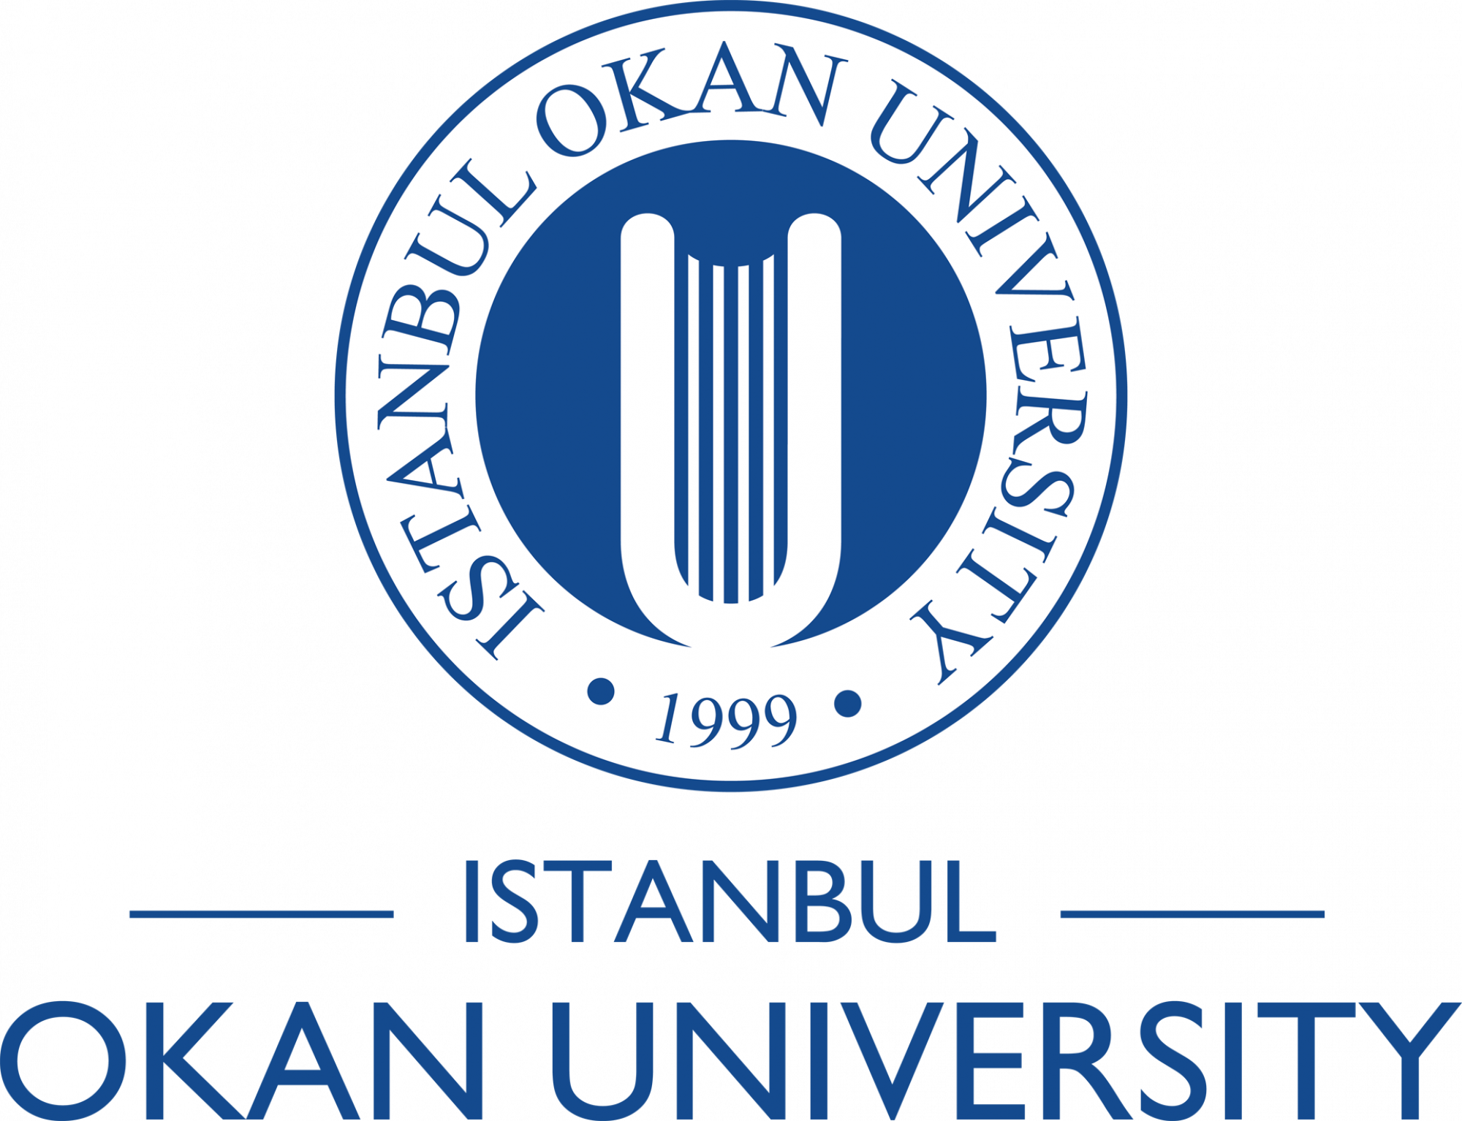
The doctoral program consists of eight semesters, regardless of whether the student registers for each semester, and the maximum time allowed for completion is twelve semesters.

Students are required to complete their coursework and prepare their thesis within the maximum period; otherwise, their affiliation with the university will be terminated.
Students are required to complete the courses specified in the curriculum within a minimum of two semesters and a maximum of four semesters.

