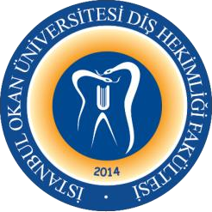
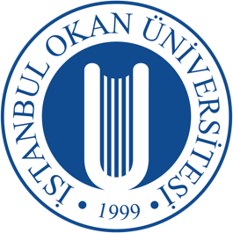
T.C.

İSTANBUL OKAN UNIVERSITY FACULTY OF DENTISTRY 2025-2026 ACADEMIC YEAR
DEPARTMENT:
COURSE CODE and NAME: DENT422 RESEARCH METHODOLOGY RESPONSIBLE FACULTY
MEMBER: Doç. Dr. Gökçe AYKOL ŞAHİN
CLASS: 4. CLASS
SEMESTER / YEAR: SPRING SEMESTER (8. SEMESTER) COURSE DAY: FRIDAY
COURSE HOURS: 14.30-15.20

WEEK | DATE | DENT422 RESEARCH METHODOLOGY THEORETICAL COURSE TOPICS | FACULTY MEMBER DELIVERING THE COURSE
1. WEEK | 30.01.2026 | Fundamentals of Scientific Research and the Scope of Research Methodology | Doç. Dr. Gökçe AYKOL ŞAHİN
2. WEEK | 6.02.2026 | Development of the Research Problem and Research Idea | Doç. Dr. Gül Merve YALÇIN ÜLKER
3. WEEK | 13.02.2026 | Formulation of Research Objectives and Hypotheses | Doç. Dr. Gül Merve YALÇIN ÜLKER
4. WEEK | 20.02.2026 | Research Designs I: Observational Studies | Doç. Dr. Müge TOKUÇ
5. WEEK | 27.02.2026 | Research Designs II: Experimental Studies | Doç. Dr. Müge TOKUÇ
6. WEEK | 6.03.2026 | Sample Selection and Definition of the Study Population | Dr. Öğr. Üyesi Melek ÇAM
7. WEEK | 13.03.2026 | Data Types and Measurement Methods | Dr. Öğr. Üyesi Gülşah YENİER YURDAGÜVEN
8-9. WEEK | 16-27.03.2026 | 1. MID-TERM EXAM
10. WEEK | 3.04.2026 | Exam Evaluation / Concepts of Validity, Reliability, and Calibration | Dr. Öğr. Üyesi Rezan SUNGUR GÜZEL
11. WEEK | 10.04.2026 | Interpretation of Statistical Results | Dr. Öğr. Üyesi Rezan SUNGUR GÜZEL
12. WEEK | 17.04.2026 | Ethical Principles in Scientific Research | Prof. Dr. Gonca MUMCU
13. WEEK | 24.04.2026 | The Role of Artificial Intelligence in Research Methodology | Doç. Dr. Cansu BÜYÜK
14. WEEK | 1.05.2026 | Practical Session I: Development of a Research Proposal | Doç. Dr. Gökçe AYKOL ŞAHİN
15. WEEK | 8.05.2026 | Presentation of Research Proposals | Doç. Dr. Gökçe AYKOL ŞAHİN
16. WEEK | 15.05.2026 | Practical Session II: Methodological Critique and Error Analysis | Doç. Dr. Gökçe AYKOL ŞAHİN
 | 1-12.06.2026 | FINAL EXAM WEEK
 | 29-03.08.2026 | CONDITION EXAM

