 |  | T.C.
 | 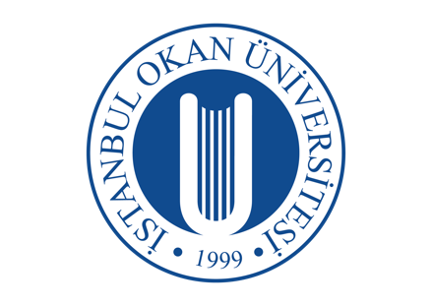 | ISTANBUL OKAN UNIVERSITY
 |  | FACULTY OF DENTISTRY | 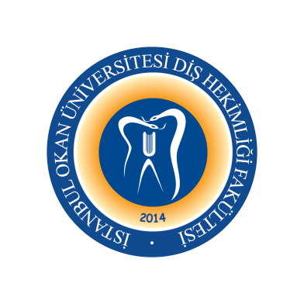
 |  | 2025-2026 ACADEMIC YEAR
DEPARTMENT: |  | RESTORATIVE DENTAL TREATMENT
COURSE CODE AND TITLE: |  | DENT413 RESTORATIVE DENTAL TREATMENT III
LECTURER: |  | Prof. Dr. Haşmet ULUKAPI
CLASS: |  | 4thCLASS
SEMESTER |  | FALL - SPRING SEMESTERS (7th - 8th SEMESTERS)
DAY: |  | Friday
TIME: |  | 13.30-14.20
WEEK | DATE | DENT313 RESTORATIVE DENTAL TREATMENT II THEORETICAL COURSE TITLES | LECTURER
WEEK 1 | September 12, 2025 | Development Abnormalities I | Asst. Prof. Gülşah Yenier YURDAGÜVEN
WEEK 2 | September 19, 2025 | Development Abnormalities II | Asst. Prof. Gülşah Yenier YURDAGÜVEN
WEEK 3 | September 26, 2025 | Development Abnormalities III | Asst. Prof. Gülşah Yenier YURDAGÜVEN
WEEK 4 | October 3, 2025 | Development Abnormalities IV | Asst. Prof. Gülşah Yenier YURDAGÜVEN
WEEK 5 | October 10, 2025 | Bleaching in Dentistry - Dental Bleaching  (Home and Power Bleaching) | Asst. Prof. Dr. Merve KÜTÜK ÖMEROĞLU
WEEK 6 | October 17, 2025 | Bleaching in Dentistry  (Microabrasion) | Asst. Prof. Dr. Merve KÜTÜK ÖMEROĞLU
WEEK 7 | October 24, 2025 | Curing Lights and Curing Procedures | Asst. Prof. Dr. Merve KÜTÜK ÖMEROĞLU
October 27-November 7, 2025 |  | 1st MID-TERM EXAM WEEKS
WEEK 8 | November 14, 2025 | Laminate Veneer Restorations (Composite Resine) | Asst. Prof. Dr. Işıl DOĞRUER
WEEK 9 | November 21, 2025 | Diastema Closure | Asst. Prof. Dr. Işıl DOĞRUER
WEEK 10 | November 28, 2025 | Inlays | Asst. Prof. Dr. Işıl DOĞRUER
WEEK 11 | December 5, 2025 | Onlays | Asst. Prof. Dr. Işıl DOĞRUER
WEEK 12 | December 12, 2025 | Laminate Veneer Restorations (Ceramic)  (CAD-CAM Aplications I) | Asst. Prof. Melek ÇAM
WEEK13 | December19, 2025 | Laminate Veneer Restorations (Ceramic)  CAD-CAM Aplications II | Asst. Prof. Melek ÇAM
WEEK 14 | December 26, 2025 | Restorations of Endodontically Treated Teeth | Asst. Prof. Dr. Buket KAYNAR
December 22, 2025 – January 2, 2026 |  | 2nd MID-TERM EXAM WEEKS
January 5 -23, 2026 |  | SEMESTER HOLIDAY
WEEK 1 | January 30, 2026 | Restorations of Endodontically Treated Teeth  (Fiber Reinforced Restorations) | Asst. Prof. Dr. Buket KAYNAR
WEEK 2 | February 6, 2026 | Postoperative Sensitivity I | Asst. Prof. Gülşah Yenier YURDAGÜVEN
WEEK 3 | February 13, 2025 | Postoperative Sensitivity II | Asst. Prof. Gülşah Yenier YURDAGÜVEN
WEEK 4 | February 20, 2026 | Atraumatic Restorative Treatment | Asst. Prof. Dr. Buket KAYNAR
WEEK 5 | February 27, 2026 | Gerontology  (Ozon Application on Caries Therapy I) | Asst. Prof. Melek ÇAM
WEEK 6 | March 6, 2026 | New Devices in Caries Diognosis | Asst. Prof. Dr. Işıl DOĞRUER
WEEK 7 | March 13, 2026 | Indirect Pulp Capping | Asst. Prof. Dr. Gülşah YENİER
WEEK 8 | March 20, 2026 | RAMADAN
March 16-27, 2026 |  | 3rd MID-TERM EXAM WEEKS
WEEK 10 | April 3, 2026 | EXAM EVALUATION | ALL PROFESSOR
WEEK 11 | April 10, 2026 | Direct Pulp Capping | Asst. Prof. Dr. Gülşah YENİER
WEEK 12 | April 17, 2026 | Restoration Repair (Amalgam)  Restoration Repair (Composite)  Fracture of Restoration | Asst. Prof. Işıl DOĞRUER
WEEK 13 | April 24, 2026 | Caries Removal Techniques I | Asst. Prof. Dr. Melek ÇAM
WEEK 14 | May 1, 2026 | PUBLIC HOLLIDAY
WEEK 15 | May 8, 2026 | Caries Removal TechniquesII | Asst. Prof. Dr. Melek ÇAM
WEEK16 | May 15, 2026 | Laser in Restorative Dentistry | Asst. Prof. Melek ÇAM
June 01-12, 2026 |  | FINAL EXAM WEEKS
June 29-July 3, 2026 |  | MAKE-UP WEEK

