 |  | T.C.
 | 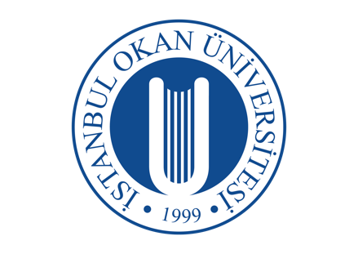 | ISTANBUL OKAN UNIVERSITY
 |  | FACULTY OF DENTISTRY | 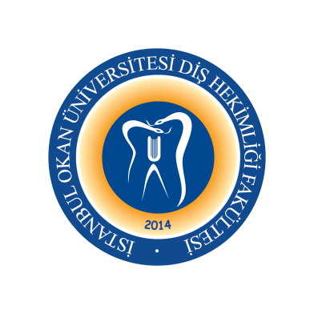
 |  | 2024-2025 ACADEMIC YEAR
DEPARTMENT: |  | RESTORATIVE DENTAL TREATMENT
COURSE CODE AND TITLE: |  | DENT313 RESTORATIVE DENTAL TREATMENT II
LECTURER: |  | Prof. Dr. Haşmet ULUKAPI
CLASS: |  | 3rd CLASS
SEMESTER |  | FALL - SPRING SEMESTERS (5th - 6th SEMESTERS)
DAY: |  | TUESDAY
TIME: |  | 15.30-16.20
WEEK | DATE | DENT313 RESTORATIVE DENTAL TREATMENT II THEORETICAL COURSE TITLES | LECTURER
WEEK 1 | September 9, 2025 | ORIENTATION
WEEK 2 | September 16, 2025 | Ergonomics in Clinical Practice | Asst. Prof. Dr. Gülşah YENİER
WEEK 3 | September 23, 2025 | Definition of Dental Caries, Hard Tissue Physico-Chemical Properties | Asst. Prof. Dr.Merve KÜTÜK ÖMEROĞLU
WEEK 4 | September 30, 2025 | Determination and Evaluation of DMFT / DFT Indexes  ICDAS-Classification and Caries Classifications,  Indexes, Clinical and Radiographic Evaluation | Asst. Prof. Dr. Gülşah YENİER
WEEK 5 | October 7, 2025 | Etiology of Dental Caries  (Structure and Microorganisms of Oral Biofilm) | Asst. Prof. Dr. Işıl DOĞRUER
WEEK 6 | October 14, 2025 | Etiology of Dental Caries (Caries and Nutrition) | Asst. Prof. Dr. Işıl DOĞRUER
WEEK 7 | October 21, 2025 | Etiology of Dental Caries (Saliva) | Asst. Prof. Dr. Işıl DOĞRUER
October 27-November 7, 2025 |  | 1st MID-TERM EXAM WEEKS
WEEK 8 | November 11, 2025 | Etiology of Dental Caries  (Oral Immunological Factors) | Asst. Prof. Dr. Işıl DOĞRUER
WEEK 9 | November 18, 2024 | Predisposing Factors - Faulty Restorations | Asst. Prof. Dr. Melek ÇAM
WEEK 10 | November 19, 2025 | Enamel Caries (Enamel Caries Pathobiology) | Asst. Prof. Dr. Melek ÇAM
WEEK 11 | November 25, 2025 | Dentin Caries (Dentin Caries Pathobiology) | Asst. Prof. Dr. Melek ÇAM
WEEK 12 | December 2, 2025 | Cementum Caries (Cementum Caries Pathobiology) | Asst. Prof. Dr. Melek ÇAM
WEEK13 | December 9, 2025 | Caries Types in Morphological Structure I  (Pit and Fissure Caries) | Asst. Prof. Dr. Buket KAYNAR
WEEK 14 | December 16, 2025 | Caries Types in Morphological Structure II  (Flat Surface Caries, Approximal Caries, Root Caries) | Asst. Prof. Dr. Buket KAYNAR
December 22, 2025 – January 2, 2026 |  | 2nd MID-TERM EXAM WEEKS
January 5 -23, 2026 |  | SEMESTER HOLIDAY
WEEK 1 | January 27, 2026 | EVALUATION OF MIDTERM EXAM
WEEK 2 | February 3, 2026 | Caries Types in Morphological Structure III  (White Caries, Acute Caries, Chronic Caries, Secondary Caries, Radiation Caries, Wet-dry Caries) | Asst. Prof. Dr. Buket KAYNAR
WEEK 3 | February 10, 2026 | Definition of Caries Risk and Risk Group Determination / Individual Caries Prophylaxis / Evaluation of Saliva Buffering Capacity, Evaluation of Saliva Flow Rate, Lactobacillus and Mutans Count in Saliva, Individual Preventive Treatment Planning, Determination of Dental Caries Risk | Asst. Prof. Dr. Işıl DOĞRUER
WEEK 4 | February 17, 2026 | Oral Care Products, Toothpastes and Mouthwashes /  Evaluation of Oral Care Level and  Providing Oral Care Training | Asst. Prof. Dr. Işıl DOĞRUER
WEEK 5 | February 24, 2026 | Remineralization Agents  (Fluoride, Arginine, Novamin Preparations) | Asst. Prof. Dr. Buket KAYNAR
WEEK 6 | March 3, 2026 | Remineralization Agents  (Resin Infiltration Technique and Laser Methods) | Asst. Prof. Dr. Buket KAYNAR
WEEK 7 | March 10, 2026 | Preventive Interventions for Bacterial Plaque  (Plaque Disclosing, Mechanical Removal, Antibacterial Agents, Mouthwashes) | Asst. Prof. Dr. Buket KAYNAR
March 23 – April 3, 2026 |  | 17 Mart 2026
WEEK 8 | March 31, 2026 | Fissure Sealant Application (Non-Invasive), Fissure Sealant Application (Invasive), Preventive Resin Application | Asst. Prof. Dr. Buket KAYNAR
WEEK 9 | April 7, 2026 | Noncarious Dental Hard Tissue Loss  (Abrasion, Abfraction, Atrision, Tooth Erosion) | Asst. Prof. Dr. Gülşah YENİER
WEEK 10 | April 14, 2026 | Noncarious Dental Hard Tissue Loss I  (Abrasion, Abfraction, Atrision, Tooth Erosion) | Asst. Prof. Dr. Gülşah YENİER
WEEK 11 | April 21, 2026 | Dentin Hypersensitivity, Treatment of Dentin Hypersensitivity with Chemical Agents, Laser Treatment of Dentin Hypersensitivity, Treatment of Dentin Hypersensitivity by Restoration | Asst. Prof. Dr. Melek Çam
WEEK 12 | April 28, 2026 | Noncarious Dental Hard Tissue Loss (Treatment)  Vertical Dimension Loss and Treatment | Asst. Prof. Dr. Işıl DOĞRUER
WEEK 13 | May 5, 2026 | Dental Hard Tissue Loss due to Trauma | Asst. Prof. Dr. Melek ÇAM
WEEK14 | May 12, 2026 | Tooth Discoloration | Asst. Prof. Dr. Buket KAYNAR
June 1-10, 2026 |  | FINAL EXAM WEEKS
June 15-19, 2026 |  | MAKE-UP WEEK

