 | 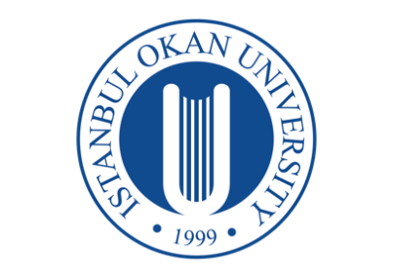 | T.C.
 |  | ISTANBUL OKAN UNIVERSITY | 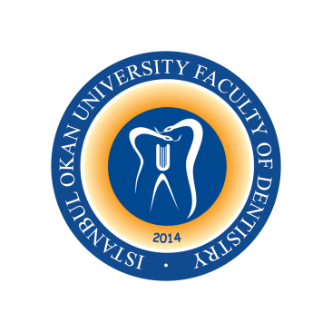
 |  | FACULTY OF DENTISTRY
 |  | 2025-2026 ACADEMIC YEAR
DEPARTMENT: |  | MULTIDICIPLINARY
COURSE CODE and TITLE: |  | DENT114 HISTORY OF DENTISTRY
LECTURER: |  | ASST. PROF. MÜGE TOKUÇ
CLASS: |  | 1st CLASS
SEMESTER: |  | SPRING SEMESTER (2nd SEMESTER)
DAY: |  | MONDAY
TIME: |  | 14.30 – 15.20
WEEK | DATE | DENT114 HISTORY OF DENTISTRY | LECTURER
WEEK 1 | 9 February 2026 | Orientation
WEEK 2 | 16 February 2026 | History of Dentistry (Introduction and Early Ages) | Asst. Prof. Dr. Bahar GÜRPINAR
WEEK 3 | 23 February 2026 | History of Dentistry (16th-18th Century) | Asst. Prof. Dr. Bahar GÜRPINAR
WEEK 4 | 2 March 2026 | History of Dentistry (19-20th Centuries) | Asst. Prof. Dr. Bahar GÜRPINAR
WEEK 5 | 9 March 2026 | History of Turkish Dentistry | Asst. Prof. Dr. Bahar GÜRPINAR
WEEK 6 | 16 March 2026 | Dentomaxillofacial Radiology: General Information and History | Asst. Prof. Cansu BÜYÜK
WEEK 7 | 23 March 2026 | Restorative Dentistry: General Information and History | Asst. Prof. Dr. Gülşah YENİER YURDAGÜVEN
WEEK 8 | 30.03 – 10.04.2026 | MID-TERM EXAM
WEEK 9 | 13 April 2026 | Pedodontics: General Information and History | Asst. Prof. Dr. Irmak BEKTAŞ DENİZ
WEEK 10 | 20 April 2026 | Periodontology: General Information and History | Asst. Prof. Sibel KAYAALTI YÜKSEK
WEEK 11 | 27 April 2026 | Oral and Maxillofacial Surgery: General Information and History | Asst. Prof. Dr. Üyesi Merve ÇAKIR
WEEK 12 | 4 May 2026 | Orthodontics: General Information and History | Lect. Ece KABAKCI
WEEK 13 | 11 May 2026 | Prosthodontics: General Information and History | Asst. Prof. Dr. Bahar GÜRPINAR
WEEK 14 | 18 May 2026 | Endodontics: General Information and History | Prof. Dr. Işıl KÜÇÜKAY
 | 01 – 12.06.2026 | FINAL EXAM WEEK
 | 29.06 – 03.07.2026 | MAKE-UP WEEK

