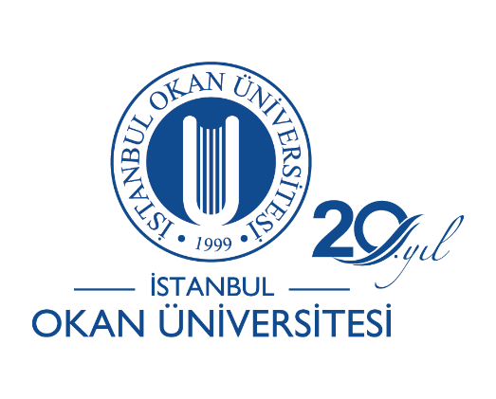

INTRODUCTORY MEETINGS OF FACULTIES/ACADEMIES
SEPTEMBER 16-18, 2019

INTRODUCTORY MEETINGS OF FACULTIES/ACADEMIES

- Faculty of Education – Monday, September 16, 2019 @ 15:00 – Mevlana Conference Hall

- PACE (Preparatory Courses) – Tuesday, September 17, 2019 @ 11:00 – Bekir Okan Conference Hall

- Faculty of Law – Monday, September 16, 2019 @ 13:30 – Faculty of Law, B101 Courthall

- Faculty of Business and Administration – Monday, September 16, 2019 @ 13:30 – Özer Ertuna Conference Hall

- Faculty of Engineering – Monday, September 16, 2019 @ 15:00 – Hezarfen Ahmet Çelebi Conference Hall

- Faculty of Medicine – Monday, September 16, 2019 @ 14:00 – Complex of Medicine, Hall T217

- College of Medicine – Formal Education: Wednesday, September 18, 2019 @ 09:30 & Thursday, September 19, 2019 @ 09:30 - Prof. Dr. Şule Kut Conference Hall
Evening Education: – Formal Education: Wednesday, September 18, 2019 @ 18:00 & Thursday, September 19, 2019 @ 18:00 - Prof. Dr. Şule Kut Conference Hall

- Faculty of Art, Desing, and Architecture – Tuesday, September 17, 2019 @ 14:00 – Mimar Sinan Conference Hall

- Faculty of Applied Sciences - Monday, September 16, 2019 @ 14:00 – Mimar Sinan Conference Hall

- Vocational School – Tuesday, September 17, 2019 @ 10:00 – Mevlana Conference Hall

White Coat Ceremonies

- White Coat Ceremony of Faculty of Medicine – Tuesday, September 17, 2019 @ 14:00 – Bekir Okan Conference Hall

- White Coat Ceremony of Faculty of Dentistry – Wednesday, September 18, 2019 @ 14:00 – Bekir Okan Conference Hall

