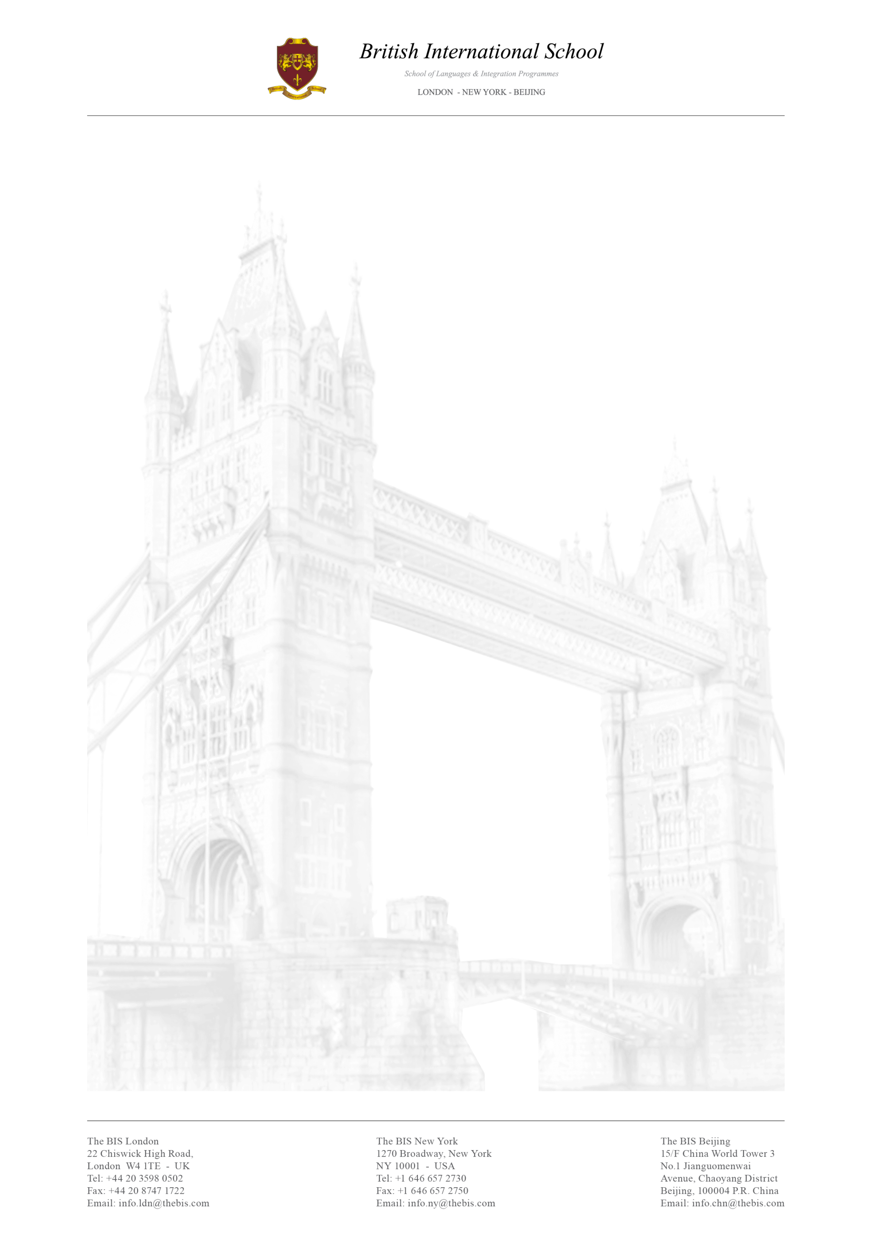

Sales Department Internship

The British International School provides outstanding English language education to students in London, New York and Beijing. Our mission is to meet the diverse needs of a constantly evolving market.
The British International School is always looking for highly motivated and talented individuals to join our team and put their knowledge into practice.

Tasks for the Sales Department positions are as follow:

- Analysing and researching the target market
- Working at our Call Centre, contacting prospective customers
- Collaborating within the department in order to create programmes and liaise with the BIS Travel Agency and other departments to book activities and programmes
- Planning and setting up new strategies to enhance the partnerships with agents

The assignment to each position will depend on the duration of the internship, availability of positions and needs of the company.

Please note that this position will predominately require the use of your mother tongue.

We are looking for motivated people with a background in Marketing, Business, Sales and Tourism.

This position is unpaid but interns have the opportunity to attend daily Business and General English classes free of charge with CELTA qualified teachers. Further advantages are the possibility to join our tours and activities throughout London as well as an international stimulating working environment.

Please feel free to send your CV to is.supervisor@thebis.com or/and hr.manager@thebis.com with the subject line: Sales Department Intern

