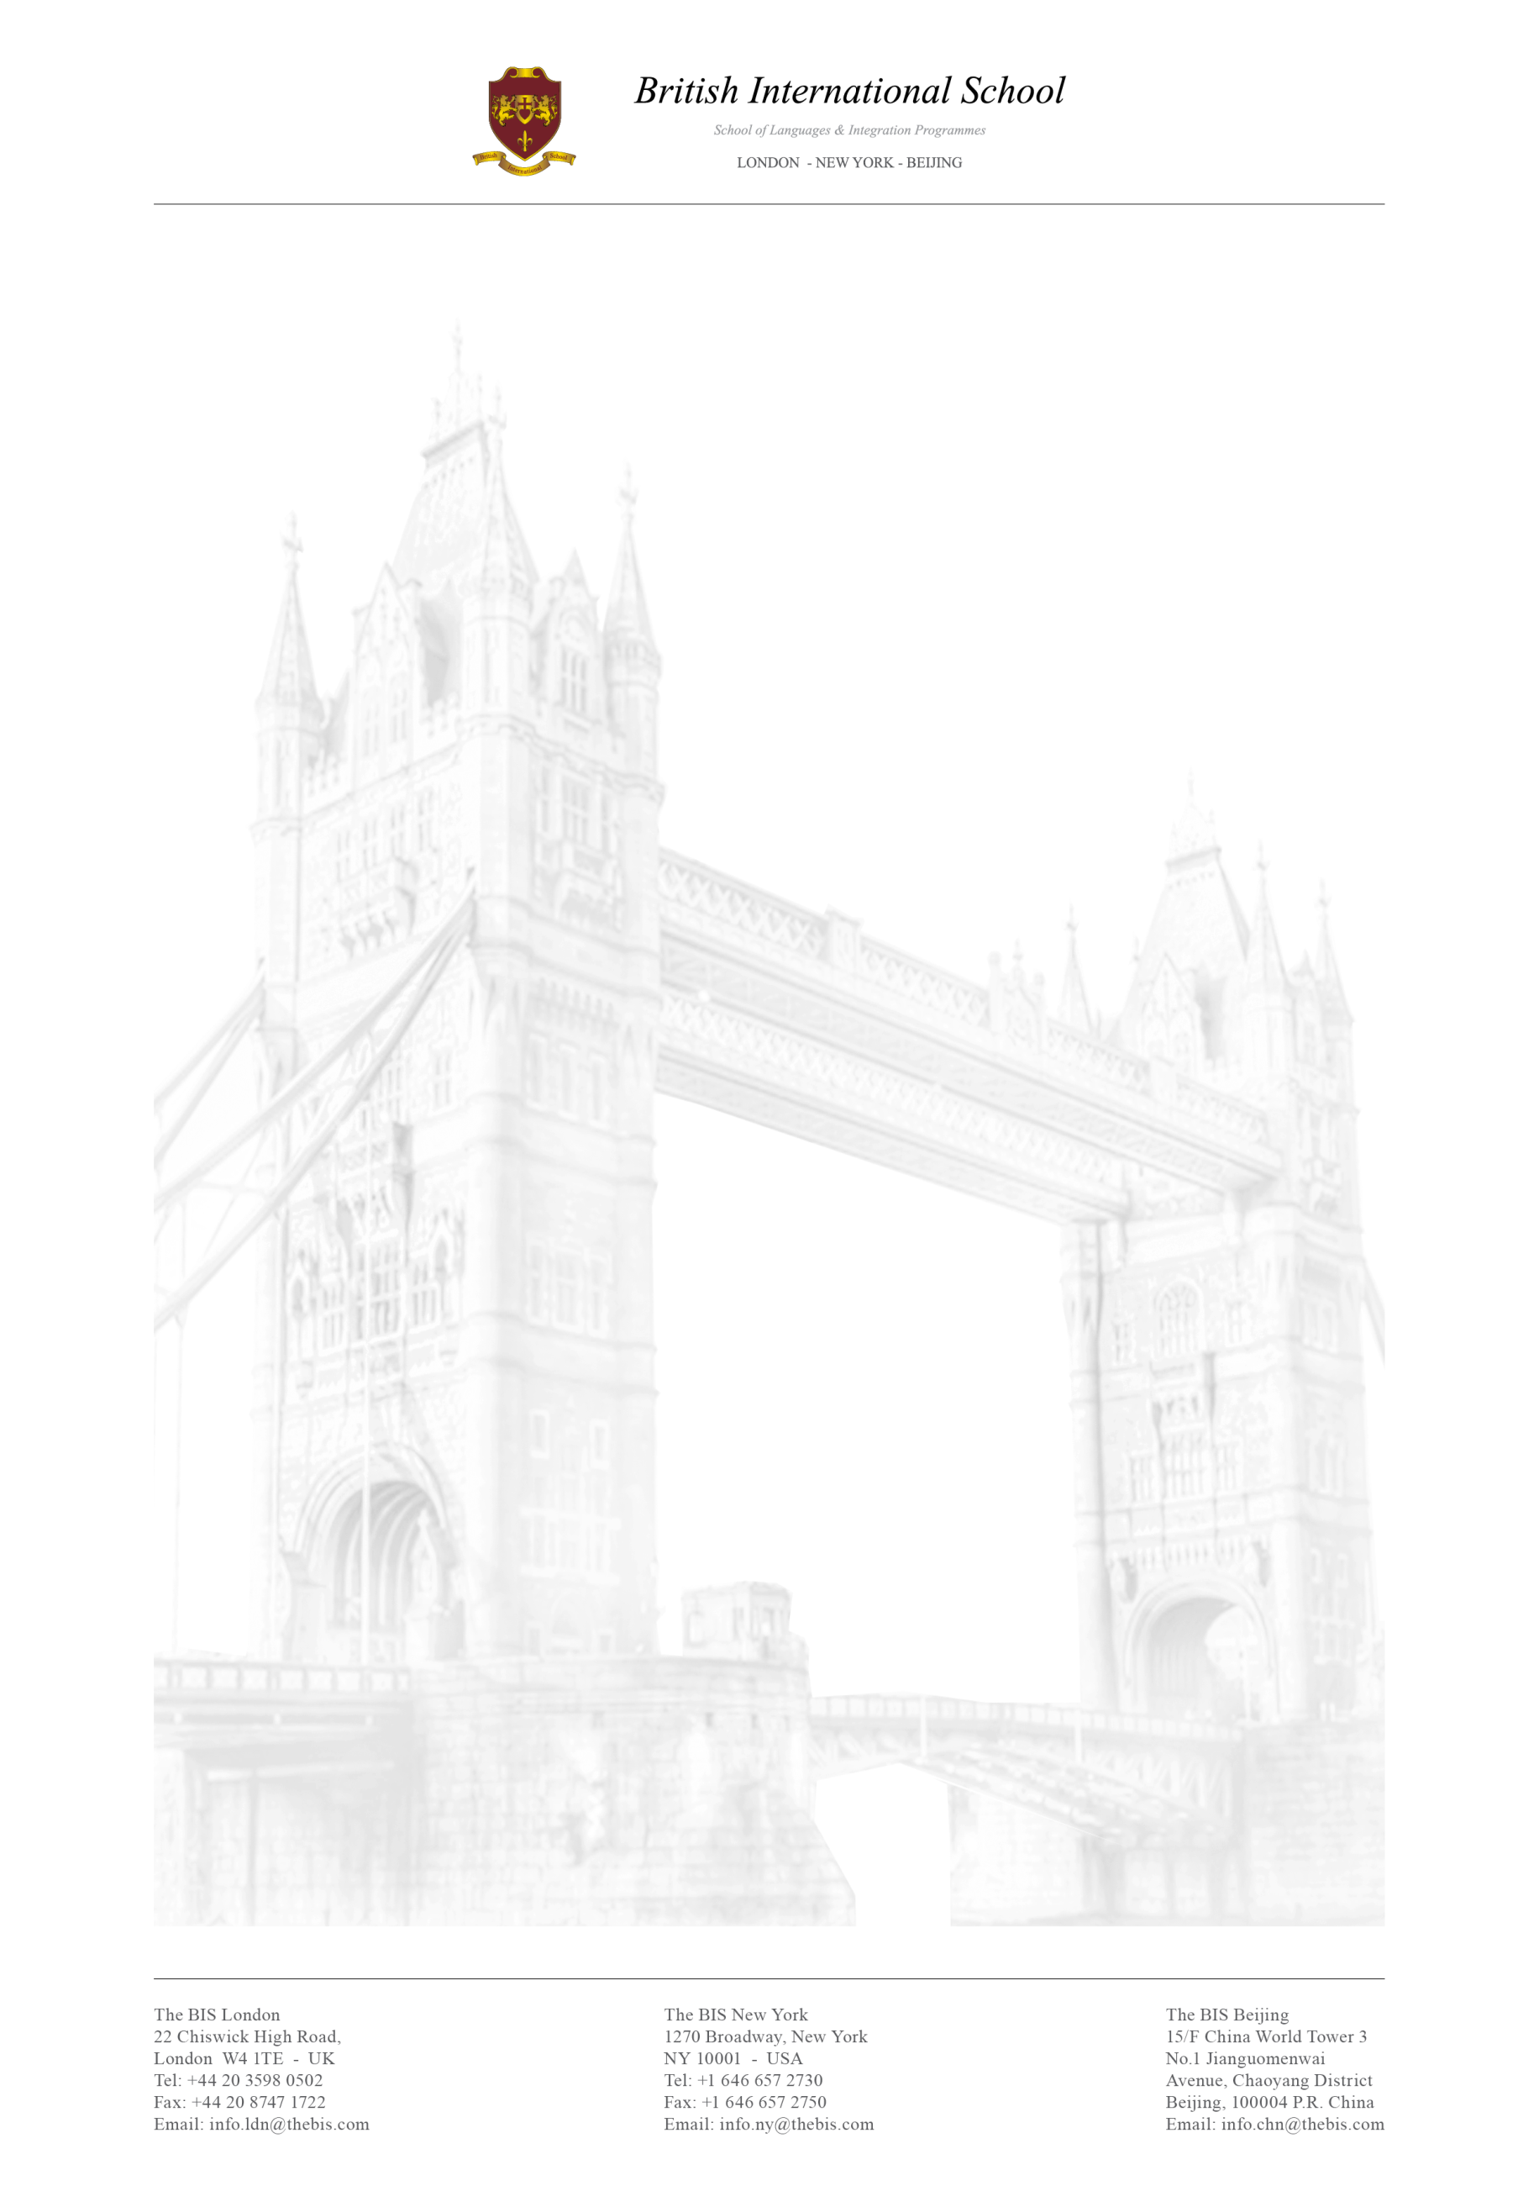

Creative Department Internship

The British International School provides outstanding English language education to students in London, New York and Beijing. Our mission is to meet the diverse needs of a constantly evolving market. The British International School is always looking for highly motivated and talented individuals to join our team and put their knowledge into practice.

Tasks for the Creative Department are:
- Graphic designer: Knowledge in Photoshop, Illustrator and InDesign required. This position is in charge of the creation of all the visual support like brochures, programmes, advertising images and many more. Video production skills will be highly appreciated.
- Community manager: High level of knowledge in social media platforms. This position is responsible for everything happening on social media. Even if the office hours are four a day, it is necessary to be available 24/7 for any emergency.
- Advertising and Public Relations: Capability in developing advertising campaigns as well as marketing research is required. Communication skills in multiple languages are appreciated and an English level of B2 is a must.
- Engine developer: It is necessary to be able to work with webmaster tools and plug-ins. There is a really close connection with the community manager.

The assignment to each position will depend on the duration of the internship, availability of positions and needs of the company. We are looking for motivated people with a background in Marketing, Graphic Design, Communication, Advertising and Public Relations.

This position is unpaid but interns have the opportunity to attend daily Business and General English classes free of charge with CELTA qualified teachers. Further advantages are the possibility to join our tours and activities throughout London as well as an international stimulating working environment.

Please feel free to send your CV to is.supervisor@thebis.com or/and hr.manager@thebis.com with the subject line: Creative+IT Department Intern

